**Note :-Take all values from the user.**

1. Calculate average of 5 numbers.

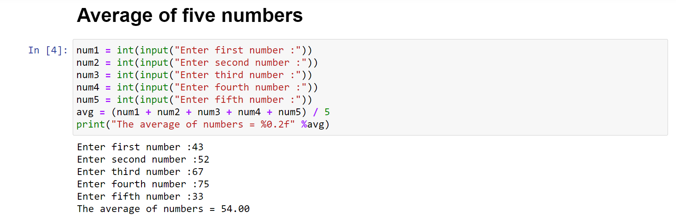

1. Check whether number is even or odd.

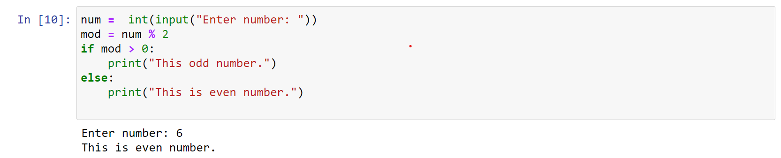

1. Take a year and check whether it is leap year or not

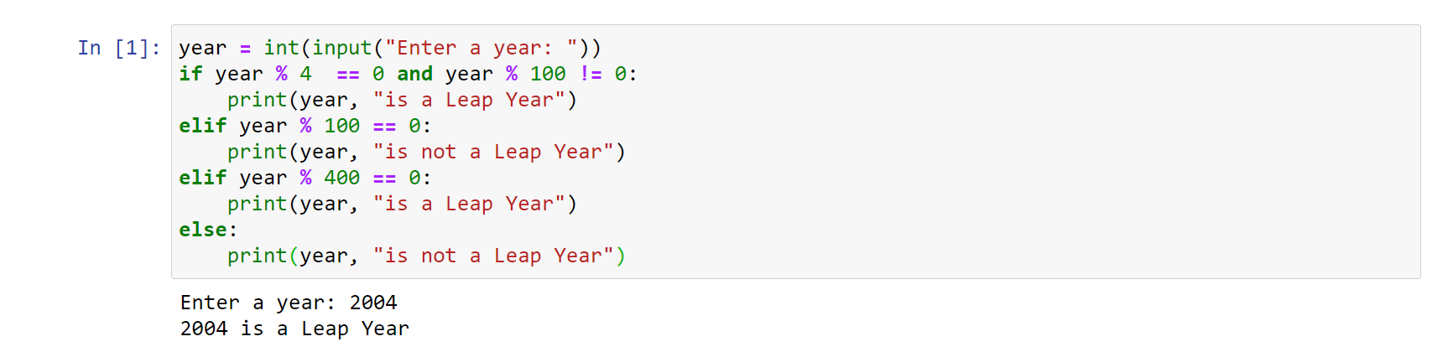

1. Take a number and check whether it is zero, positive or negative.

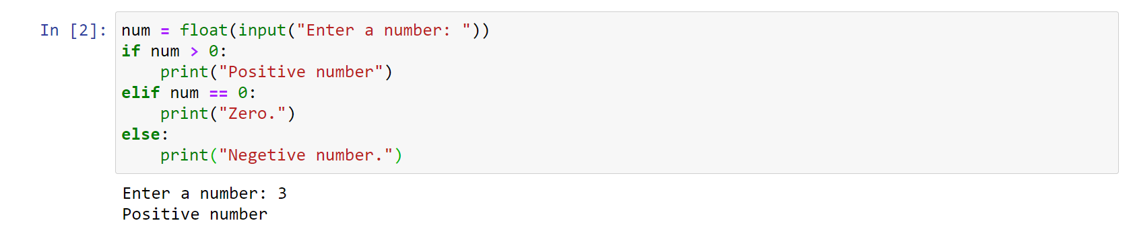

1. Take 2 numbers and display greatest number. (Also check equal number condition)

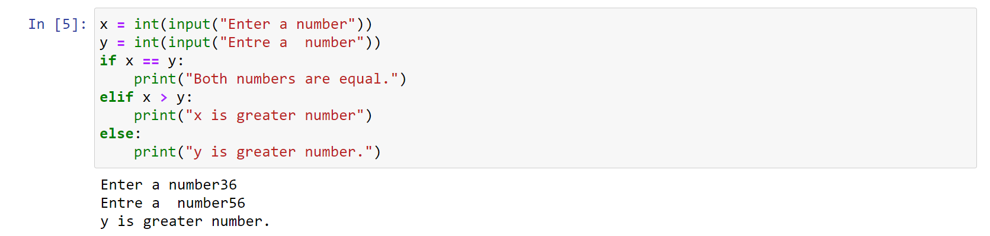

1. Take a number and find factorial of that number.

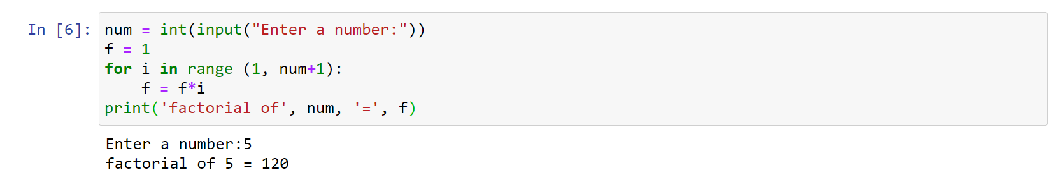

1. Write a program to swap 2 numbers using third variable.

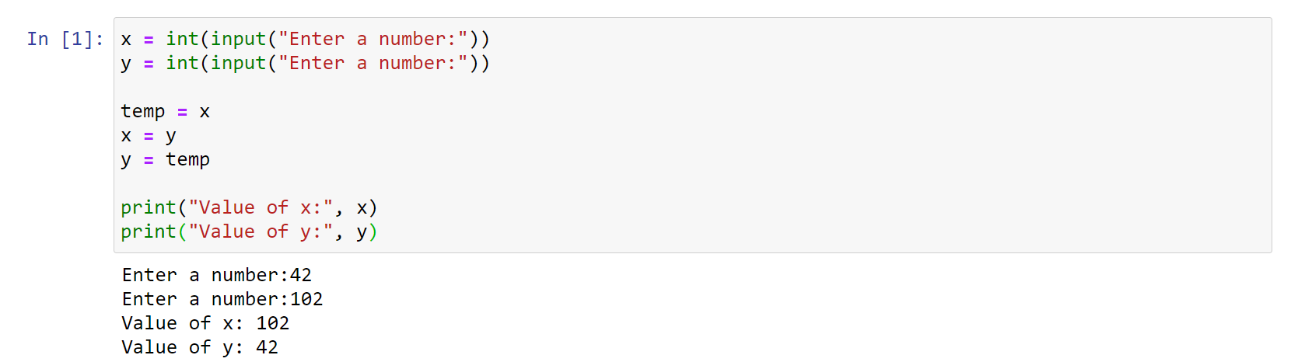

1. Take 2 numbers and find smallest number.

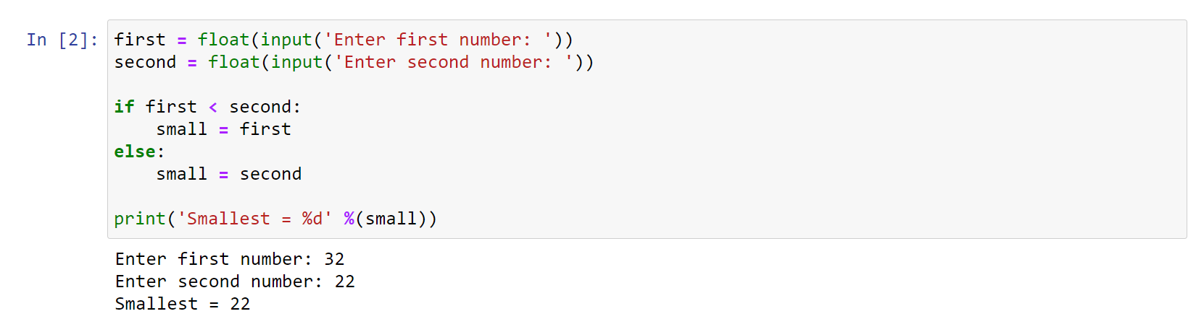

1. Take a number check if a number is less than 100 or not. If it is less than 100 then check if it is odd or even.

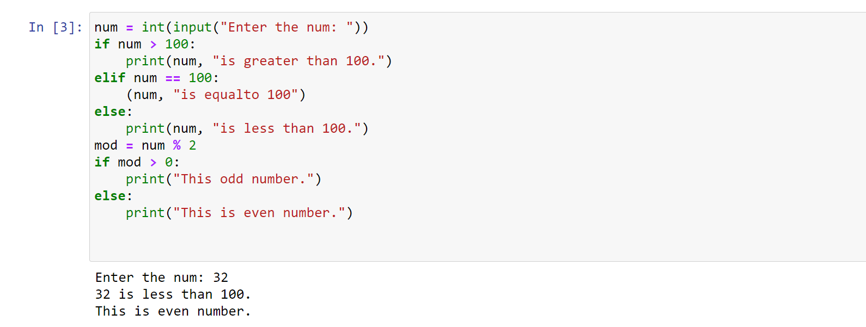

1. Take a number to print the square of a number if it is less than 10.

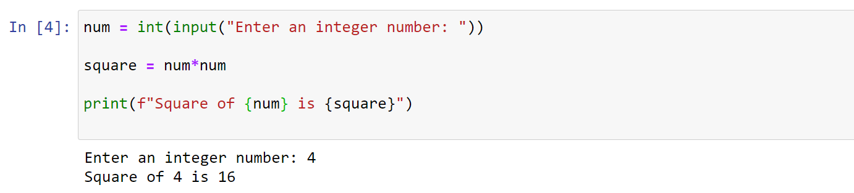

1. Take a number and check whether it is zero, positive or negative using nested IF…ELSE statement .

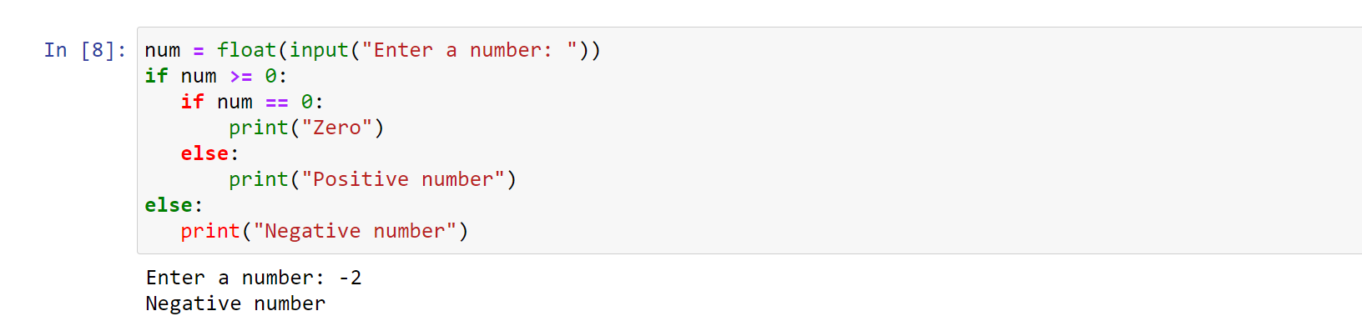

1. Take 3 numbers and find greatest number using nested IF….ELSE statement.

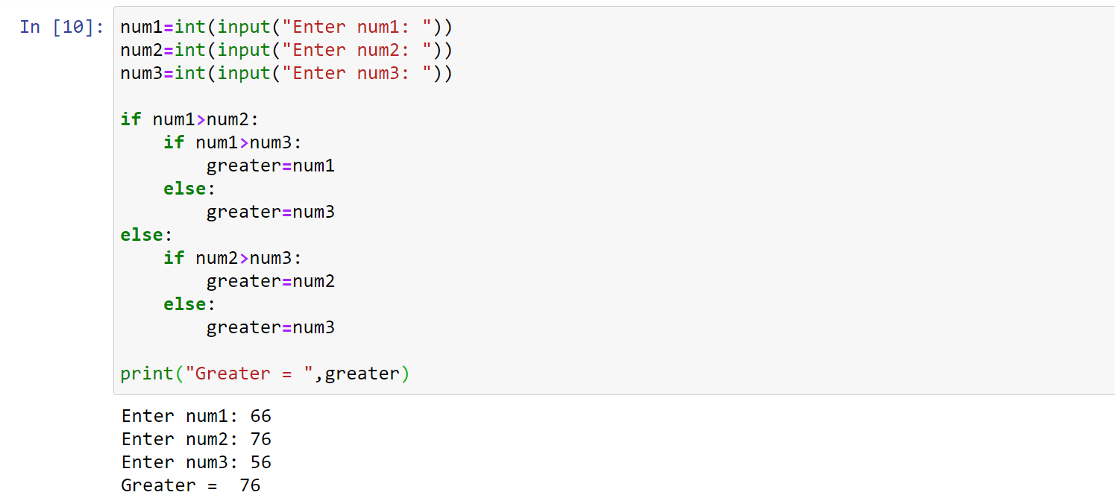

1. Take 3 numbers and find smallest number using logical operator.

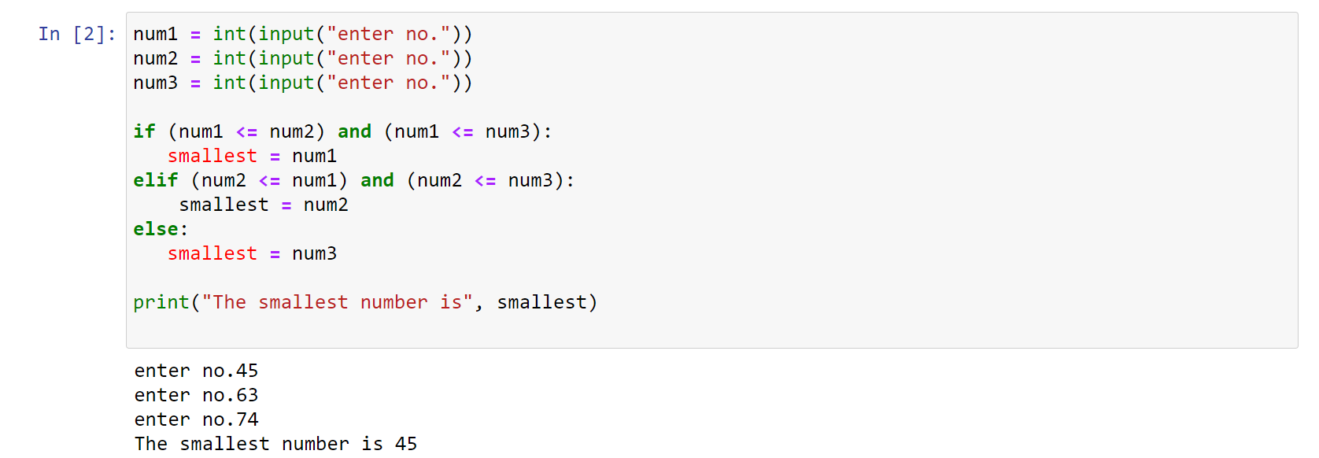

1. Write a program to swap 2 numbers without taking third variable.

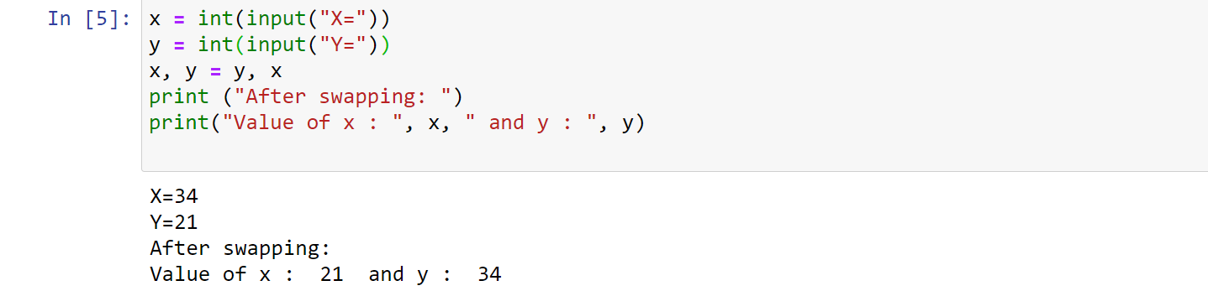

1. Take starting number and ending number from the user and print following series.

